**LabVIEW-Arduino Fire Detection System**

# Abstract

A fire alarm system is used for safety reasons in buildings. Fire alarm systems are designed to discover fires early in their development. A fire alarm system consists of different electrical components working together to detect and warn people through different appliances. To detect a fire, different sensors could be used such as heat, smoke and carbon monoxide. In basic level, the system is monitoring an area until unusual changes occur then the system start taking actions such as warning and controlling the fire. This project could save the lives of people since discovering the fire early would give them time to escape. It reduces losses especially in building where high cost machines, devices and equipment are used.

Table of Contents

Abstract 2

1. Problem Statement and High Level Architecture 4

2. Design Details 4

2.1. Hardware 4

2.2. Software 4

3. Implementation and Testing 4

4. Conclusion and future work 5

References 5

# Problem Statement and High-Level Architecture

A fire alarm system is used for safety reasons in different areas. In this project, such a system will be designed to detect a fire, control it and alert individuals about it by turning on a buzzer and a fan. The process of detecting fire will depend on two factors, fire/ and smoke. Two sensors will be used to identify the situation of the area. A microcontroller is the link between the computer and sensors.



**Fig.1.** High-level Architecture.

# Design Details

## Hardware

**Fig.2.** Connection Diagram.

Components and Tools:

* LM355 Temperature Sensor: It is a cheap temperature sensor. Calibrated directly in ° Celsius with 0.5°C accuracy (at +25°C) and Rated for full −55° to +150°C range.
* MQ2 Smoke Gas Sensor: It has high sensitivity to of LPG, i- butane, propane, methane, alcohol, Hydrogen, smoke.
* TIP31A Transistor: Designed for use in general purpose amplifier and switching applications. It has high current gain and is used to run components that require more current to operate than the Arduino can supply.
* Buzzer: It has continuous and loud beep sound at around 2300 resonant frequency.
* FAN-MF 4010: It has 5400 rpm.
* Wires, wire cutters and miscellaneous.

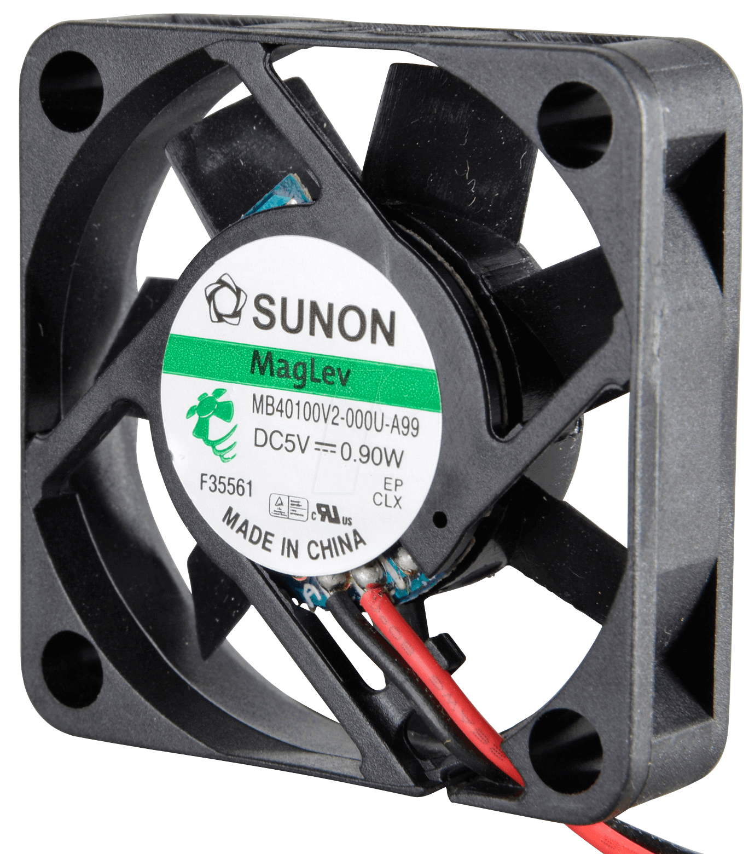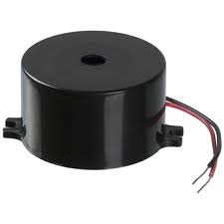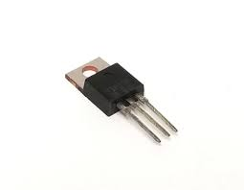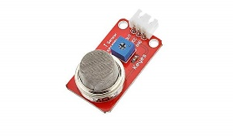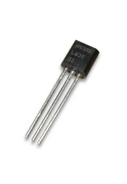

**Fig.3.** LM355. **Fig.4.** MQ3. **Fig.4.** TIP31A. **Fig.5.** Buzzer. **Fig.6.** Fan.

## Software



**Fig.7.** Logic Flowchart.

The software used to implement the fire alarm system are:

1. LabVIEW: Laboratory Virtual Instrument Engineering Workbench. It is a system-design platform and development environment for a visual programming language from National Instruments. It is a graphical and high-level language which provide efficiency in development. It has a huge number of libraries which prevent starting development from scratch. It provides tools to control and monitor a system easily.
2. LINX: provides easy to use LabVIEW VIs for interacting with common embedded platforms such as Arduino. It provides an easy way to develop embedded applications using LabVIEW

The system will keep sense the changing in temperature and smoke. This will be done by having all the logic, in LabVIEW, placed in a while loop. The values of the temperature and smoke need to be above a threshold to turn on the fan and buzzer. The design logic is fairly straightforward, this means a more robust system. The system will not work if someone is smoking in the coverage area. Moreover, the system will stay off if the dust increases around the smoking sensor.

# Implementation and Testing

In this project there were many challenges. Firstly, the fan was not working due to the low amount of current comes from the Arduino Uno microcontroller. This problem was solved by using an NPN transistor which use to current amplification. Secondly, the temperature sensor was burned because of the wrong connection. It was difficult to know if it is working or not. The first step to solve this problem was to replace all wires in the circuit and re-check the connection. Then the solution was to replace it with a potentiometer, this ensured that the connection of the other parts of the circuit was correct and proved that the problem is in the temperature sensor, so another sensor used.

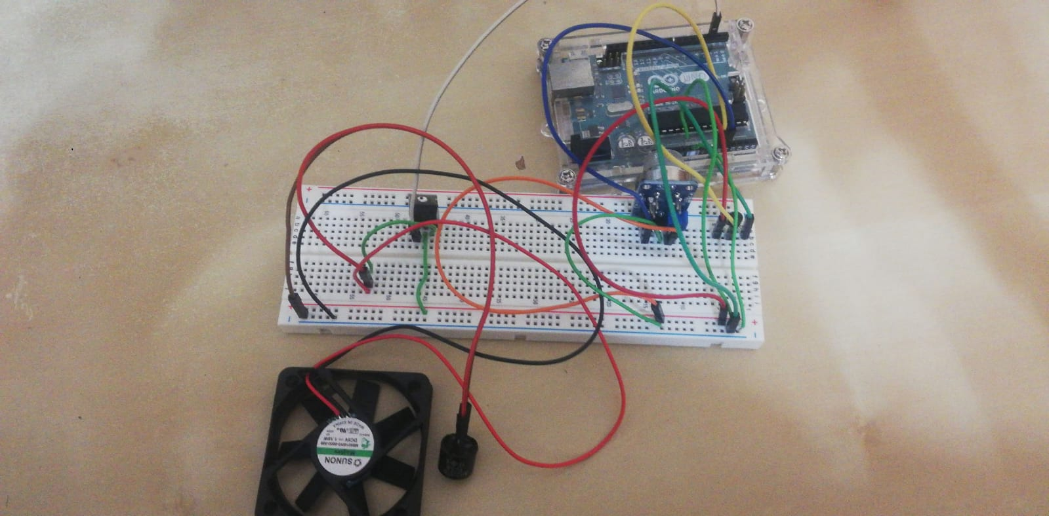

**Fig.8**. Connection Implementation.

**Fig.9.** Block Diagram.

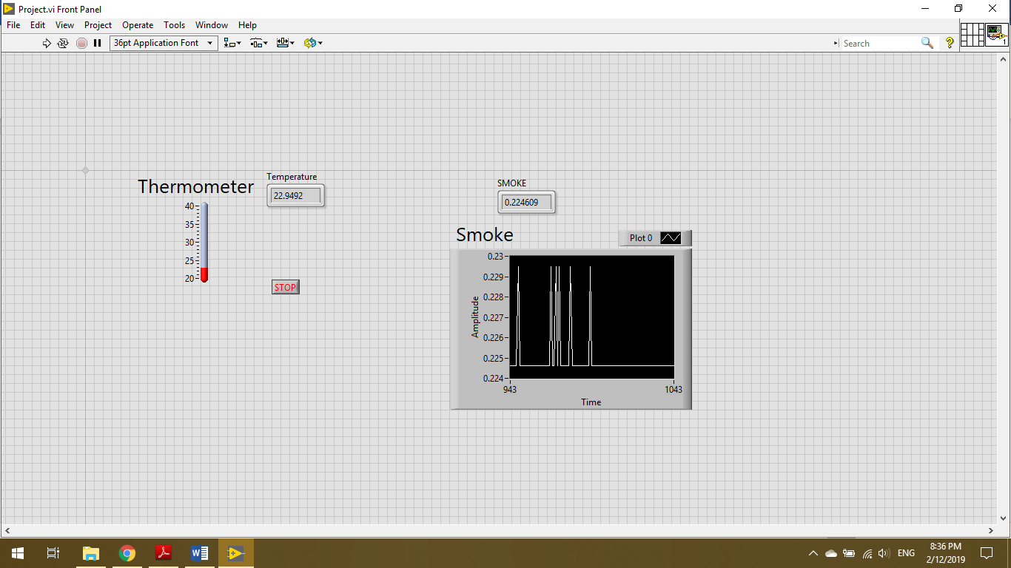

**Fig.10** LabVIEW Front Panel.

* Encountered Challenges:

1. Turning on the Fan and the Buzzer at the same initially did not work. The fan would produce a faint humming sound along with the buzzer. This was resolved by placing a transistor, TIP31A, which enables the Arduino to control loads with higher current requirements.
2. The Temperature sensor burnt due to wrongfully connecting it. This was discovered by observing its output which was illogical. The solution was to replace it by a functioning one.

* Tests:

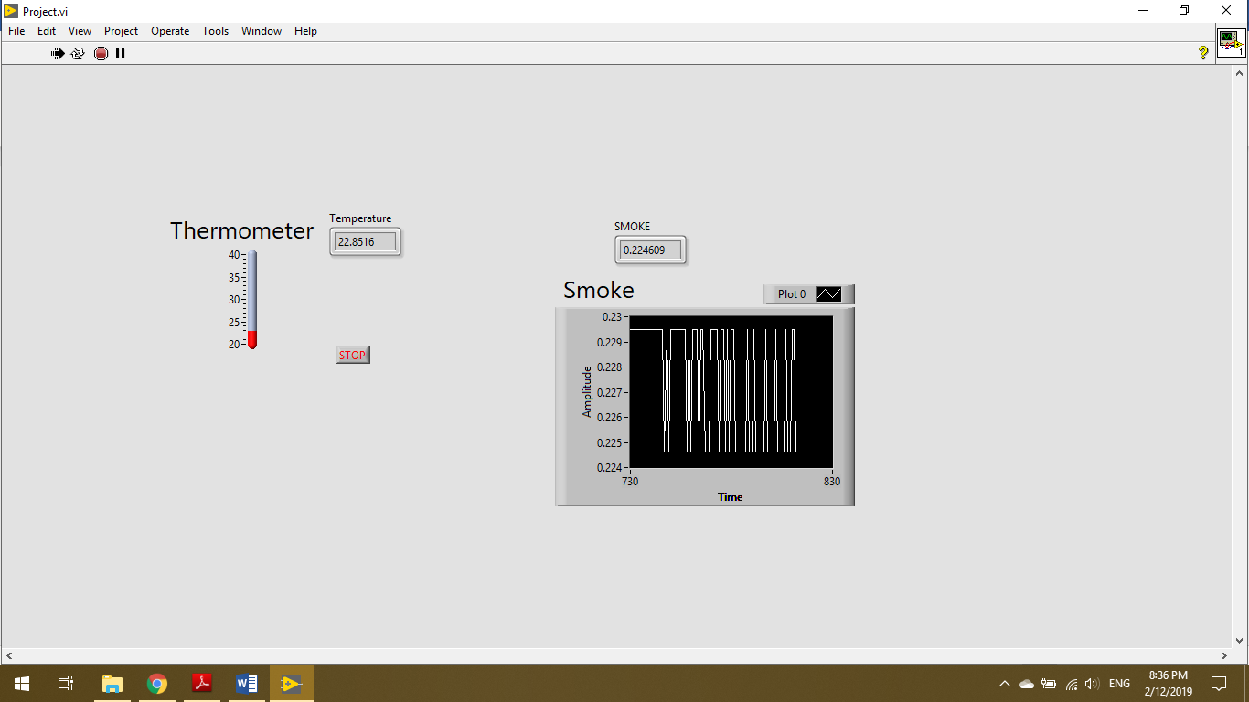

**Fig.11.** Normal Conditions.

As shown in Fig.11., the system functioning in normal conditions. And when heat is applied or smoke is present in the environment, as shown in Fig.12., the buzzer and fan both turn on. This will be done after both sensors take readings, as shown in Fig. 13.

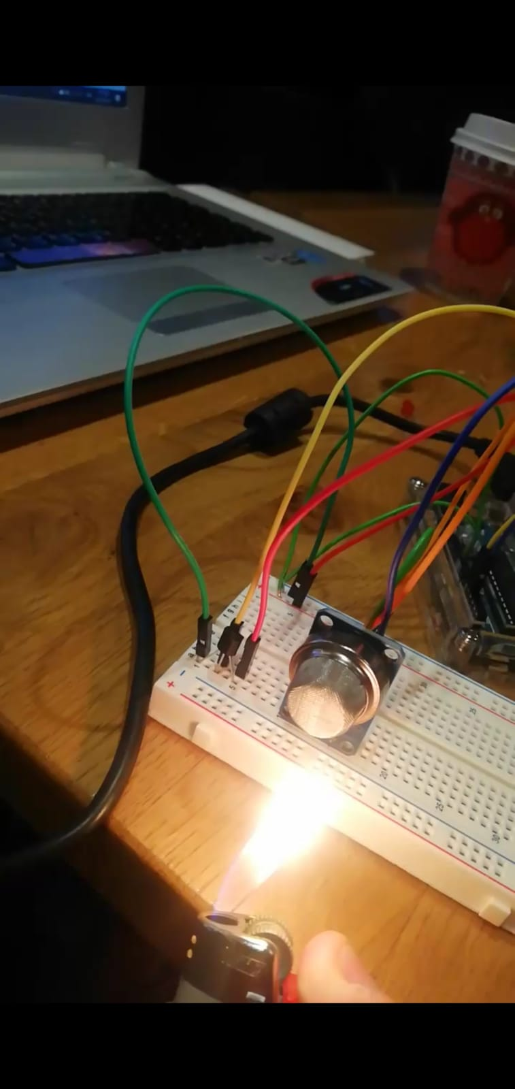

**Fig.12.** Fire is Present.

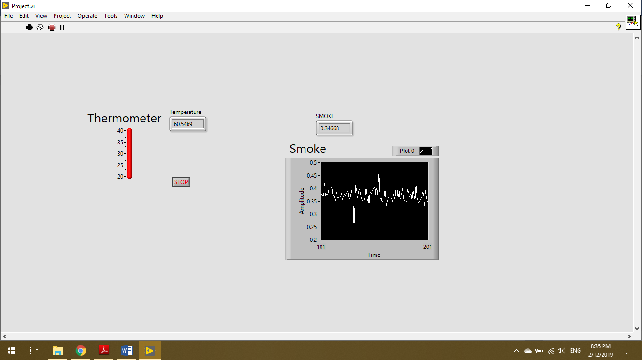

**Fig.13.** Fire is Present, Program’s readings.

* Result discussion:

The system functions as designed, and the prototype fulfills its requirements. Of course, nothing is perfect, although requirements were fulfilled, the next step would be to implement the system on a larger scale and add features such as contacting the property’s owner. This project is a gateway for further development of such systems to hopefully make an actual product.

# Conclusion and future work

Overall the project functions as required. The project works on the basis of reading the temperature and amount of smoke in an environment and determine whether there is a fire. If a fire exists, action is taken in the form of turning on a buzzer and fan. This was completely achieved. As mentioned previously, it would be interesting to see how this project may be upscaled to be a real-life product.

# References

1. “LMx35, LMx35A Precision Temperature Sensors,” Texas Instruments, Feb-2015. [Online]. Available: http://www.ti.com/lit/ds/snis160e/snis160e.pdf. [Accessed: 02-Dec-2019].
2. “TIP31G, TIP31AG, TIP31BG, TIP31CG (NPN), TIP32G,TIP32AG, TIP32BG, TIP32CG(PNP),” ON Semiconductors, Sep-2015. [Online]. Available: https://www.onsemi.com/pub/Collateral/TIP31A-D.PDF. [Accessed: 02-Dec-2019].
3. “TECHNICAL DATA MQ-2 GAS SENSOR,” HANWEI ELETRONICS. [Online]. Available: <https://www.mouser.com/datasheet/2/321/605-00008-MQ-2-Datasheet-370464.pdf>. [Accessed: 02-Dec-2019].
4. “Buzzer,” components 101, 02-Nov-2016. [Online]. Available: https://components101.com/sites/default/files/component_datasheet/Buzzer Datasheet.pdf. [Accessed: 02-Dec-2019].